LAB–3: Objects, Instance Methods & Encapsulation (Java)

Objectives
- Understand the difference between static and non-static members
- Define classes with instance variables
- Create and use objects in Java
- Call non-static methods using objects
- Understand reference variables and object aliasing
- Use constructors to initialize objects
- Apply basic encapsulation using private
- Implement getters and setters
- Use the this keyword correctly

Prerequisite
Students should have completed Lab–2 and must be familiar with static methods, control statements, arrays, and basic Java syntax.

1. Transition from Static to Object-Oriented Programming
Static methods belong to the class, whereas non-static methods belong to objects. Object-oriented programming focuses on methods operating on object data.

Example
// Static
static int add(int a, int b) { return a + b; }
// Non-static
int add(int a, int b) { return a + b; }

2. Class and Object Basics
A class is a blueprint, and an object is an instance created from that class.

Example
class Student {
String name;
int age;
}
Student s1 = new Student();

3. Instance Variables vs Local Variables
Instance variables belong to objects, while local variables exist only within methods.

Example
class Student {
String name;
void show() {
int x = 10;
}
}

4. Object Creation and Method Calling
Non-static members are accessed using objects and the dot operator.

Example
Student s1 = new Student();
s1.name = "Ali";
s1.age = 20;
s1.display();

5. Reference Variables and Object Aliasing
Multiple references can point to the same object.

Example
Student s1 = new Student();
Student s2 = s1;
s1.name = "Ali";
System.out.println(s2.name);

6. Constructors
Constructors initialize objects and are called automatically.

Example
class Student {
String name;
int age;
Student(String n, int a) {
name = n;
age = a;
}
}

7. Encapsulation
Encapsulation hides data using private and provides controlled access.

Example
class Student {
private int age;
}

8. Getters and Setters
Getters and setters access private data safely.

Example
class Student {
private int age;
void setAge(int a) { age = a; }
int getAge() { return age; }
}

9. this Keyword
this refers to the current object and resolves naming conflicts.

Example
class Student {
private int age;
void setAge(int age) {
this.age = age;
}
}

Practice Tasks
Instructions:
• All methods must be non-static (except main).
• Use private data members wherever applicable.
• Access data using constructors, getters, and setters.
• Do not write logic directly inside main.

Task 1: Student Profile Management
Create a class named Student with the following private fields:
• id (int)
• name (String)
• age (int)
• cgpa (double)
Requirements:
1. Create setters and getters for all fields.
2. Validate age (15–60) and cgpa (0.0–4.0).
3. If invalid data is provided, do not update the value and display a message.
4. Create an instance method display() to print complete student information.
In main:
• Create two Student objects.
• Set values using setters and display both objects.
class Studet{
private int id;
private String name;
private int age;
private double cgpa;
void setId(int id){
if(id<1){
System.out.println("Invalid");
}
else {
this.id=id;}
}
int getId(){
return id;
}
void setName(String name){
this.name=name;
}
String getName(){
return name;
}
void setAge(int age){
if(age>=16 && age<=60){
this.age=age;
}
else{
System.out.println("Invalid");
}
}
int getAge(){
return age;
}
void setCgpa(double cgpa){
if(cgpa>=0.00 && cgpa<=4.00){
this.cgpa=cgpa;
}
else{
System.out.println("Invalid");
}
}
double getCgpa(){
return cgpa;
}
void display(){
System.out.println("ID= " +getId());
System.out.println("Name= " +getName());
System.out.println("Age= " +getAge());
System.out.println("CGPA= " +getCgpa());
}
}
class Main{
public static void main(String args[]){
Studet s1= new Studet();
Studet s2= new Studet();
s1.setId(1);
s1.setName("Ahmed");
s1.setAge(16);
s1.setCgpa(3.5);
s2.setId(2);
s2.setName("Aliyan");
s2.setAge(18);
s2.setCgpa(3.2);
s1.display();
s2.display();
}
}
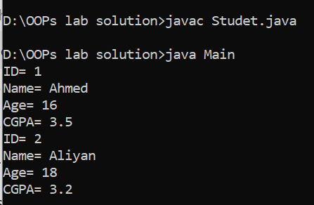

Task 2: Bank Account System
Create a class named BankAccount with the following private fields:
• accountNumber (String)
• accountHolder (String)
• balance (double)
Requirements:
1. Use a parameterized constructor to initialize all fields.
2. Create methods deposit(amount) and withdraw(amount).
3. Deposit amount must be greater than 0.
4. Withdrawal amount must be greater than 0 and less than or equal to balance.
5. Create a method getBalance() that returns current balance.
6. Create a method printStatement() to display account details.
In main:
• Create one account object.
• Perform multiple deposits and withdrawals.
• Display account details after each operation.
class BankDetail{
private String Acountnumber;
private String Acountholder;
private double balance;
BankDetail(){
this.balance=1000;
}
void setAcounthNumber(String Acountnumber ){
this.Acountnumber=Acountnumber;
}
void setAcountHolder(String Acountholder ){
this.Acountholder=Acountholder;
}
void setDepositAmount(int amount){
if (amount>0){
balance+=amount;
System.out.println("Amount deposit sucessfully");
}
else {
System.out.println("Invalid amount");
}
}
void setWithrawtAmount(double amount){
if (amount>0 && amount<=balance){
balance-=amount;
System.out.println(amount + "amount withdraw sucessfully");
}
else {
System.out.println("Invalid amount");
}
}
String getAcountNumber(){
return Acountnumber;
}
String getAcountHolder( ){
return Acountholder;}
double getDepositAmount( ){
return balance;

}
double getWithdarwAmount( ){
return balance;}
void display(){
System.out.println("----------------------------------------------");
System.out.println("Acount Number: " +getAcountNumber());
System.out.println("Acount Holder: " +getAcountHolder());
System.out.println("Current balance : " +getDepositAmount());
System.out.println("----------------------------------------------");
}
}
class Main{
public static void main(String args[]){
BankDetail p1=new BankDetail();
BankDetail p2=new BankDetail();
p1.setAcounthNumber("1011");
p1.setAcountHolder("Aliyan");
p1.setDepositAmount(4000);
p1.setWithrawtAmount(2000);
p2.setAcounthNumber("1012");
p2.setAcountHolder("Ahmed");
p2.setDepositAmount(3000);
p2.setWithrawtAmount(100);
p1.display();
p2.display();
}
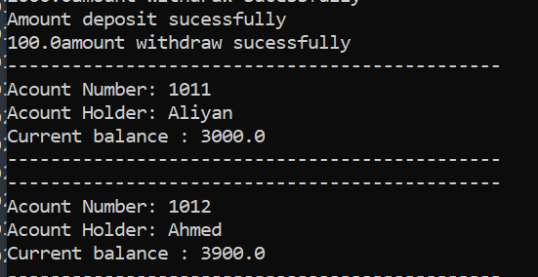
}

Task 3: Car Showroom Inventory
Create a class named Car with the following private fields:
• brand (String)
• model (String)
• year (int)
• price (double)
Requirements:
1. Create a parameterized constructor using the this keyword.
2. Create a display() method to print car details.
3. Create a getter for price only.
In main:
• Create three Car objects.
• Display all car details.
• Identify and display the most expensive car.
class CarDetail{
private String brand;
private String model;
private int year;
private double price;
public CarDetail(String brand,String model,int year,double price){
this.brand=brand;
this.model=model;
this.year=year;
this.price=price;
}
void display(){
System.out.println("---------------------------------");
System.out.println("Brand Name: " +brand);
System.out.println("Model: " +model);
System.out.println("Year: " +year);
System.out.println("Price" +price);
System.out.println("---------------------------------");
}

}
class Main{
public static void main(String args[]){
CarDetail s1=new CarDetail("BMW","23",2023,400000);
s1.display();
}
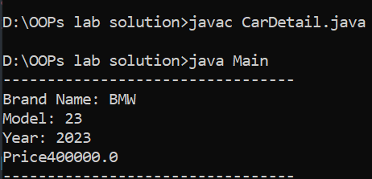
}

Task 4: Reference and Object Aliasing Demonstration

Create a class named Box with the following fields:
• length (double)
• width (double)
Requirements:
1. Create an instance method area() that returns the area.
2. In main:
• Create one Box object and assign values.
• Create another reference pointing to the same object.
• Modify dimensions using the second reference.
• Print area using both references.
Observation:
• Both references should reflect the same updated area.
class Box{
private double length;
private double width;

public Box(double length,double width){
this.length=length;
this.width=width;
}
void setLength(double length){
this.length=length;
}
void setWidth(double width){
this.width=width;
}

double area(){
return length*width;
}
}
class Main{
public static void main(String args[]){
Box b1=new Box(5,7);
System.out.println("Before using box1: " +b1.area());
Box b2=b1;
b2.setLength(10);
b2.setWidth(9);
System.out.println("After using Box1 Afte modification: " +b1.area());
System.out.println("After using BOx2 After modification: " +b2.area());

}
}
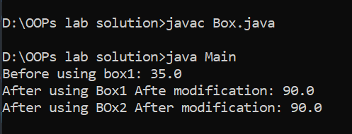

Task 5: Employee Salary Calculator
Create a class named Employee with the following private fields:
• employeeId (int)
• name (String)
• basicSalary (double)
Requirements:
1. Create setters and getters with validation (basicSalary ≥ 30000).
2. Create methods:
• hra() → returns 20% of basic salary
• tax() → returns 5% of basic salary
• netSalary() → returns basic + hra − tax
• printSlip() → prints formatted salary slip
In main:
• Create two Employee objects.
• Display salary slips for both employees.
class EmployDetail{
private int id;
private String name;
private double salary;
EmployDetail(int id,String name,double salary){
this.id=id;
this.name=name;
this.salary=salary;
}
void setId(int id){
this.id=id;
}
void setName(String name){
this.name=name;
}
void setBasicSalary(double salary) {
if(salary>=30000){
this.salary=salary;
}
else{
System.out.println("Insufficient salary");
this.salary=30000;
}
}
int getId(){
return id;
}
String getName(){
return name;
}
double getBasicSalary(){
return salary;
}

double hra(){
return 0.2*salary;
}
double tax(){
return 0.05*salary;
}
double netSalary(){
return salary+hra()-tax();
}
void display(){
System.out.println("-------------------------------");
System.out.println("ID: " +id);
System.out.println("Name: " +name);
System.out.println("Basic Salary: " +salary);
System.out.println("HRA: " +hra());
System.out.println("Tax: " +tax());
System.out.println("Net Salary: " +netSalary());
System.out.println("----------------------------------");
}
}
class Main{
public static void main(String args[]){
EmployDetail E1=new EmployDetail(1,"Aliyan", 50000);
EmployDetail E2=new EmployDetail(2,"Ahmed", 60000);
E1.display();
E2.display();

}
}
